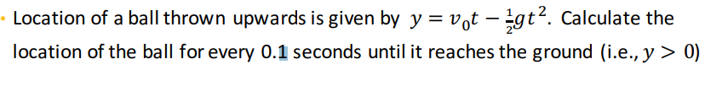

Let v0=20

|  |  |
| --- | --- |
| Slv:  v0=20;  g=9.8;  t=0;  y=0;  time=0;  location=0;  while y>=0  disp(['AT time t=',num2str(t),' Location=',num2str(y)]);  y=v0*t-g*t^2/2;  t=t+0.1;  time=[time, t]; #to plot we keeping value #at a row matrix  location=[location, y];#to plot we #keeping value at a row matrix  end  plot(time,location, '--')#for ploting, time is x #axis value and location is y axis value ,in side ‘-- ’ plotting #sign  xlabel('Time(s)'); # label  ylabel('Location(m)'); #lebel | Output:  AT time t=0 Location=0  AT time t=0.1 Location=0  AT time t=0.2 Location=1.951  .  .  .  AT time t=4.1 Location=1.6 |
| Here in the plot function we can use  ‘g’ and ‘o’  ‘g’ means grean color and ‘o’ ball  plot(time,location, '--go') |  |